_____________________________________________________________________________________
Amy Singer, Ph.D.

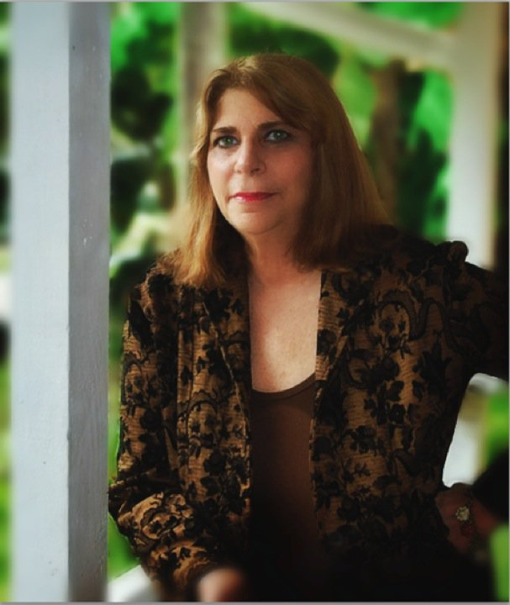
Amy Singer, Ph.D. is a licensed psychologist who is an expert in statistical methodologies, data analysis, and applied research. Singer’s firm, Trial Consultants, Inc., which she founded in Miami in 1979, is one of the first trial consulting firms in the United States. Singer is pioneer and nationally acknowledged authority in the field of litigation psychology, a discipline that provides jury selection, focus groups, social media analytics, shadow juries, venue studies, witness preparation and trial strategy. Singer continues to serve as a popular and prolific author, trial consultant, and speaker contributing her expertise to national publications, broadcast media, legal associations and high-profile cases such as the Casey Anthony, Dr. Kevorkian, Michael Jackson, William Kennedy Smith and O. J. Simpson trials.

Singer has written numerous professional articles on litigation research, trial consulting, trial presentation, voir dire, jury focus groups, witness preparations and related topics. These articles have been published in leading legal and trial magazines, including Trial, Trial Lawyers Quarterly, The Practical Litigator, Trial Diplomacy Journal, Leader's Product Liability, Law Office Economics & Management, Wiley Expert Witness Update, The Law Works, and many others. She also authored The Psychologist and the Jury, Matthew Bender Publishers.

With attorney Pat Maloney, Singer is the co-author of the three-volume Trials and Deliberations: Inside the Jury Room, a compilation of transcriptions and analyses of mock jurors' real-life discussions concerning every conceivable civil trial proceeding, including numerous medical malpractice areas, as well as cases concerning defamation, slip and fall, products liability, commercial disputes, and many more. The book was the first of its kind to provide actual juror deliberations regarding virtually every cause and/or action for civil trial disputes, as well as professional commentary interpreting the significance of the case-by-case deliberations. Shepards/McGraw-Hill published the book in 1992. Additionally, Singer has been a contributing author to the Wiley Expert Witness Update, published by Wiley Law Publications.

In addition to her many bylined articles and books, Singer and/or her professional practice have been cited in numerous publications, including The New York Times, The Wall Street Journal, Psychology Today, Ladies' Home Journal, The Boston Globe, The Miami Herald, Fort Lauderdale Sun-Sentinel, Orlando Business Journal, St. Petersburg Times, Los Angeles Daily Journal, San Francisco Daily Journal, The American Lawyer, The Miami Daily Business Review, and Lawyers Weekly USA.
- Please see http://www.trialconsultants.com/singerpublications.html

Trial Consultants, Inc.
1463 N.W. 104th Drive
Gainesville, FL. 32606
www.trialconsultants.com
amy.trialconsultants@gmail.com
(954) 648 – 7521
Education and Certification
Hofstra University
B.A. – 1975 M.A., 1977 - Ph.D,1978
Magna cum laude, dean's list, and Psi Chi National Honor Society

Singer is a licensed clinical psychologist who taught Social Psychology, statistics and research methods at Hofstra University as an associate professor. From 1982 to 1984, Singer was a part-time member of the Department of Psychology, Florida International University, Miami-Dade County, Florida where she taught research methods and design. She also taught the "Psychology of Jury Selection" at Nova Southeastern University law school, Fort Lauderdale.

Honors and Memberships
American Society of Trial Consultants
American Psychological Association
_______________________________
Jury Research - Trial Preparation
Interactive Focus Groups - Jury Selection
Post-Verdict Interviews - Simultaneous Juries
Supplemental Juror Questionnaires
Witness Preparation - Jury Simulations
Community Attitude Surveys – Mock Trials

